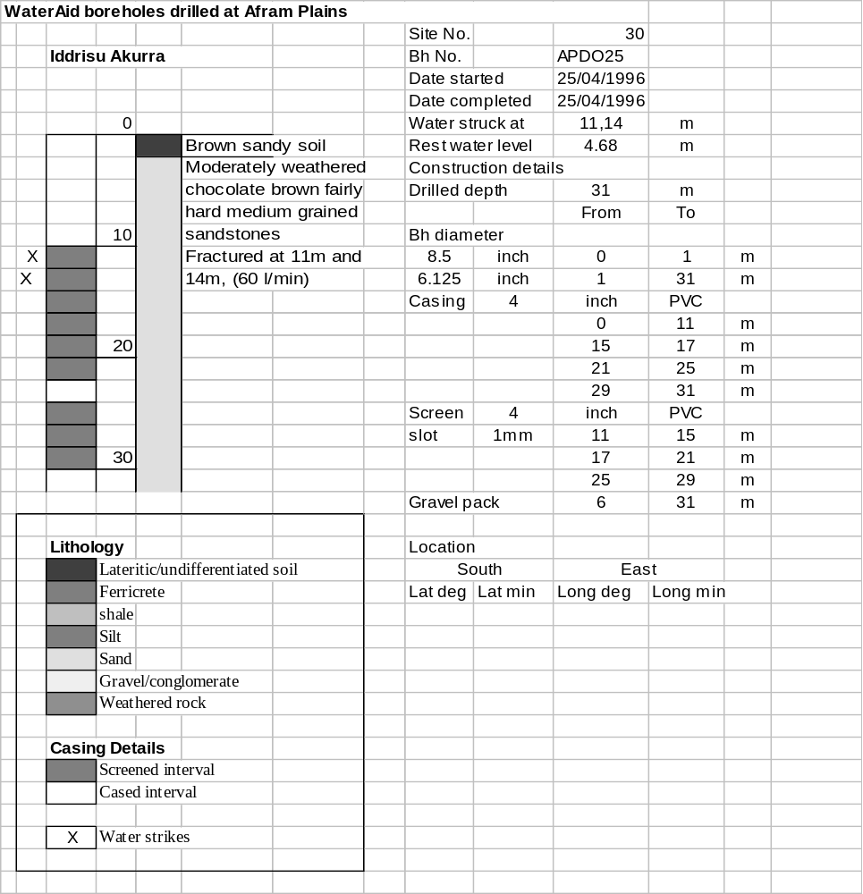

Ghana | Test pumping
Borehole No. |  | APDO25
Hole No |  | 30
Village |  | Iddrisu Akuraa
Date |  | 27/04/1996
Point above GL |  | 0.5 | m
Pump depth |  | 23 | m
SWL |  | 5.18 | m
Start Time |  | 09:30
Drawdown test |  |  |  |  | Recovery test
time | pwl (m) | Q l/min | s (m) | sc | Time | wl (m) | s' (m) | t/t'
0.00 | 5.18 | 100.00 | 0.00 |  | 0.00 | 13.30 | 8.12
1.00 | 6.55 | 100.00 | 1.37 | 72.99 | 1.00 | 11.66 | 6.48 | 181.00
2.00 | 6.80 | 100.00 | 1.62 | 61.73 | 2.00 | 11.49 | 6.31 | 91.00
3.00 | 6.99 | 100.00 | 1.81 | 55.25 | 3.00 | 11.37 | 6.19 | 61.00
4.00 | 7.13 | 100.00 | 1.95 | 51.28 | 4.00 | 11.28 | 6.10 | 46.00
5.00 | 7.28 | 100.00 | 2.10 | 47.62 | 5.00 | 11.21 | 6.03 | 37.00
6.00 | 7.42 | 100.00 | 2.24 | 44.64 | 6.00 | 11.15 | 5.97 | 31.00
7.00 | 7.56 | 100.00 | 2.38 | 42.02 | 7.00 | 11.09 | 5.91 | 26.71
8.00 | 7.69 | 100.00 | 2.51 | 39.84 | 8.00 | 11.04 | 5.86 | 23.50
9.00 | 7.81 | 100.00 | 2.63 | 38.02 | 9.00 | 10.99 | 5.81 | 21.00
10.00 | 7.96 | 100.00 | 2.78 | 35.97 | 10.00 | 10.94 | 5.76 | 19.00
11.00 | 8.05 | 100.00 | 2.87 | 34.84 | 12.00 | 10.85 | 5.67 | 16.00
12.00 | 8.15 | 100.00 | 2.97 | 33.67 | 14.00 | 10.75 | 5.57 | 13.86
13.00 | 8.25 | 100.00 | 3.07 | 32.57 | 16.00 | 10.69 | 5.51 | 12.25
14.00 | 8.34 | 100.00 | 3.16 | 31.65 | 18.00 | 10.60 | 5.42 | 11.00
15.00 | 8.43 | 100.00 | 3.25 | 30.77 | 20.00 | 10.52 | 5.34 | 10.00
16.00 | 8.52 | 100.00 | 3.34 | 29.94 | 22.00 | 10.45 | 5.27 | 9.18
17.00 | 8.61 | 100.00 | 3.43 | 29.15 | 24.00 | 10.37 | 5.19 | 8.50
18.00 | 8.69 | 100.00 | 3.51 | 28.49 | 26.00 | 10.32 | 5.14 | 7.92
19.00 | 8.77 | 100.00 | 3.59 | 27.86 | 28.00 | 10.25 | 5.07 | 7.43
20.00 | 8.85 | 100.00 | 3.67 | 27.25 | 30.00 | 10.19 | 5.01 | 7.00
22.00 | 9.00 | 100.00 | 3.82 | 26.18 | 35.00 | 10.04 | 4.86 | 6.14
24.00 | 9.15 | 100.00 | 3.97 | 25.19 | 40.00 | 9.90 | 4.72 | 5.50
26.00 | 9.30 | 100.00 | 4.12 | 24.27 | 45.00 | 9.77 | 4.59 | 5.00
28.00 | 9.43 | 100.00 | 4.25 | 23.53 | 50.00 | 9.65 | 4.47 | 4.60
30.00 | 9.61 | 100.00 | 4.43 | 22.57 | 60.00 | 9.41 | 4.23 | 4.00
35.00 | 9.86 | 100.00 | 4.68 | 21.37 | 70.00 | 9.21 | 4.03 | 3.57
40.00 | 10.14 | 100.00 | 4.96 | 20.16 | 80.00 | 9.03 | 3.85 | 3.25
45.00 | 10.41 | 100.00 | 5.23 | 19.12 | 90.00 | 8.85 | 3.67 | 3.00
50.00 | 10.66 | 100.00 | 5.48 | 18.25 | 100.00 | 8.70 | 3.52 | 2.80
55.00 | 10.89 | 100.00 | 5.71 | 17.51 | 110.00 | 8.55 | 3.37 | 2.64
60.00 | 11.12 | 100.00 | 5.94 | 16.84 | 120.00 | 8.43 | 3.25 | 2.50
70.00 | 11.52 | 100.00 | 6.34 | 15.77
80.00 | 11.86 | 100.00 | 6.68 | 14.97
90.00 | 12.09 | 100.00 | 6.91 | 14.47
100.00 | 12.26 | 100.00 | 7.08 | 14.12
110.00 | 12.44 | 100.00 | 7.26 | 13.77
120.00 | 12.63 | 100.00 | 7.45 | 13.42
130.00 | 12.87 | 100.00 | 7.69 | 13.00
140.00 | 13.05 | 100.00 | 7.87 | 12.71
160.00 | 13.20 | 100.00 | 8.02 | 12.47
180.00 | 13.30 | 100.00 | 8.12 | 12.32
